

Visual Programming
Lab #3 Strings in C#
SUBMITTED BY:
UBAID AHMAD
ROLL NO:
2410-0011
SUBMITTED TO:
Sir Aaish Khan
DATE:
06/10/2026

Task 1:
Q1. Create a basic calculator in C# Console. Input must be taken from user for every calculation.
Code:
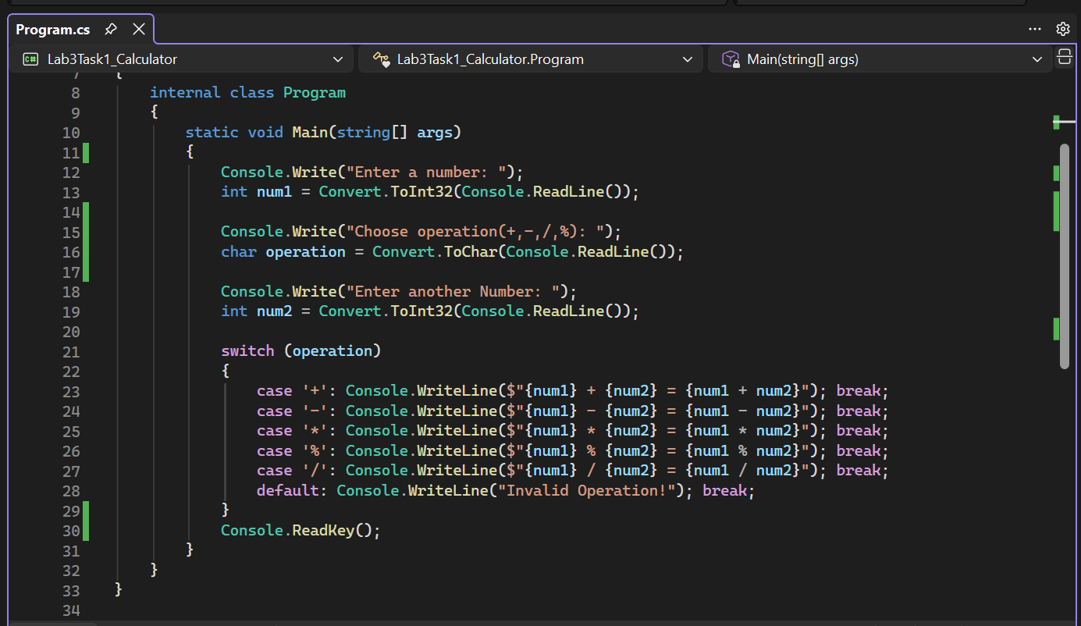
OUTPUT:
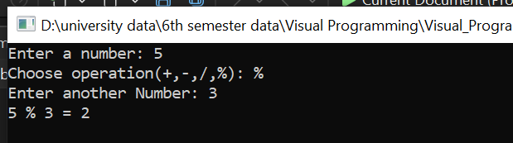

Task 2:
Q2. Write a C# program that asks the user to enter their full name and then displays the name in uppercase, lowercase, and also shows the total number of characters in it using string methods. Replace the space between first and last name with underscore (_).
CODE:
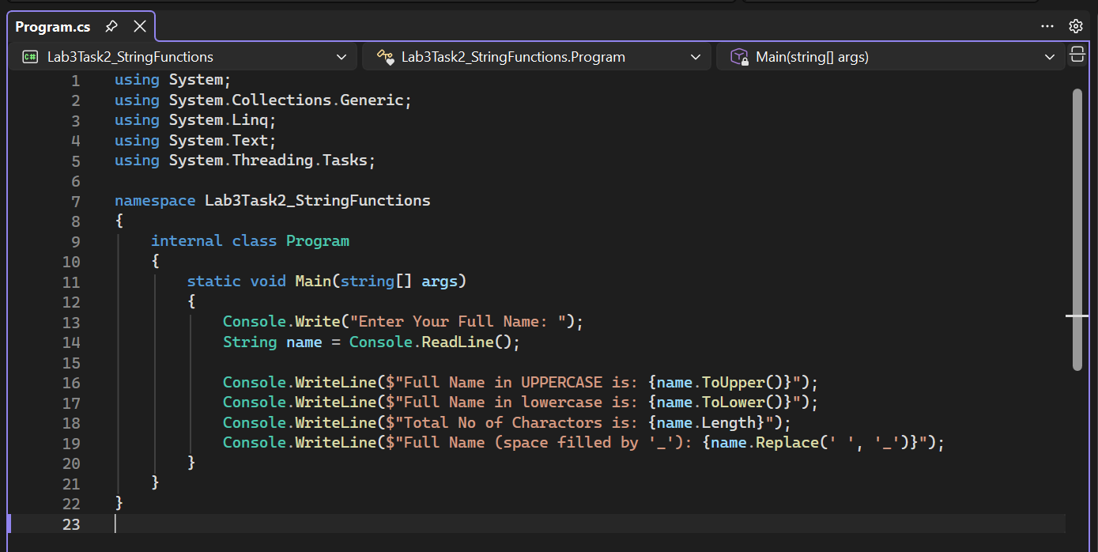
OUTPUT:
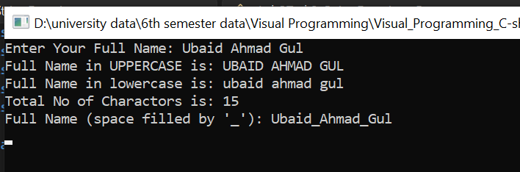

Task 3:
Q3. Use Math functions to perform advance functions of calculator i.e., rounding off a value, calculating square root finding out max or min value from multiple use inputs. To store values for constant variables, use constants of C# i.e., pi value etc.
CODE:
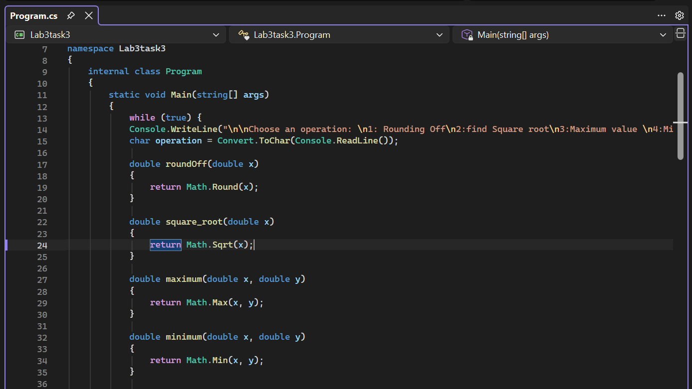
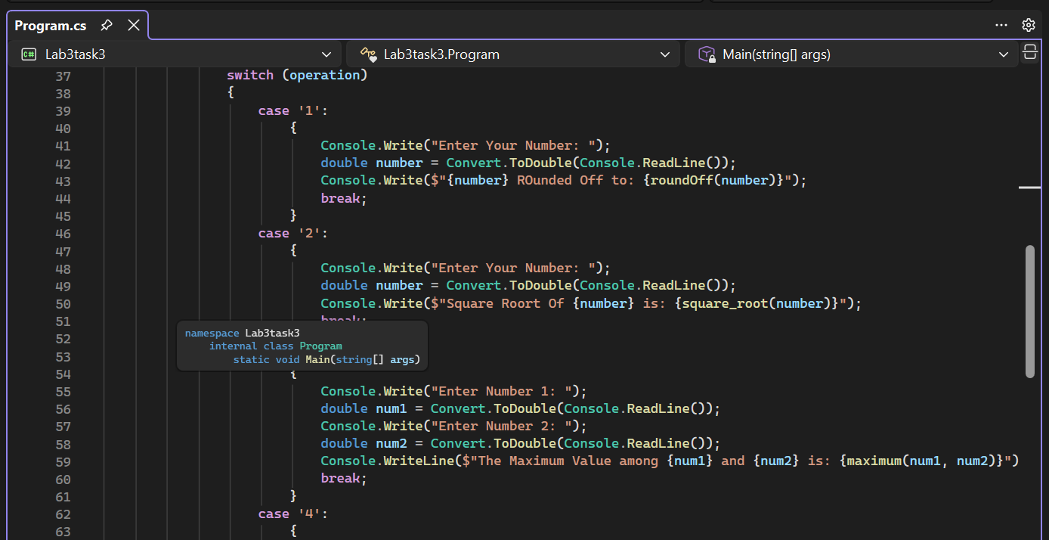
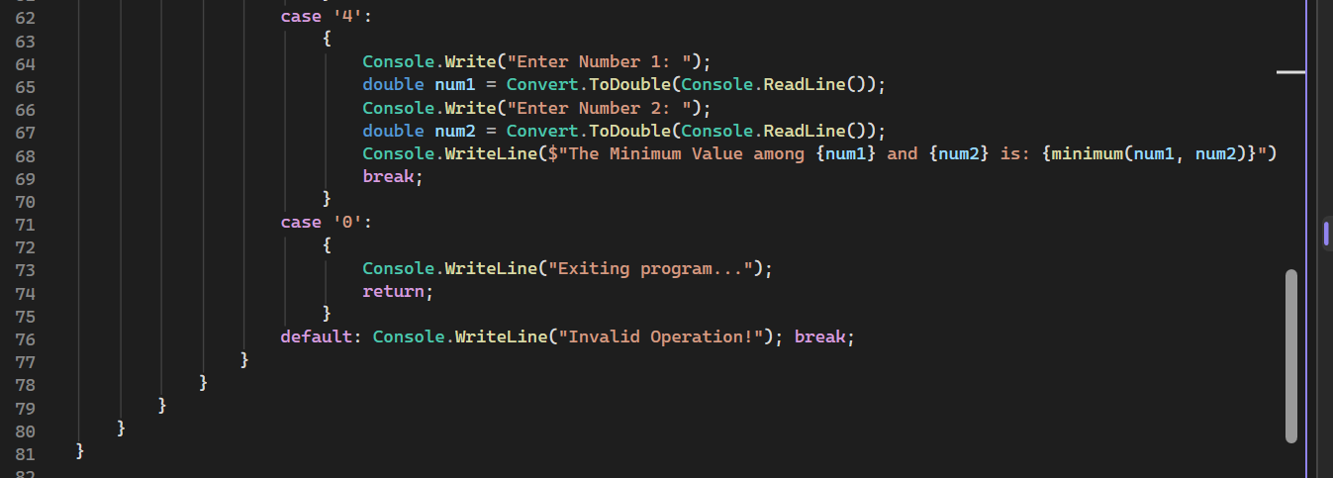
OUTPUT:
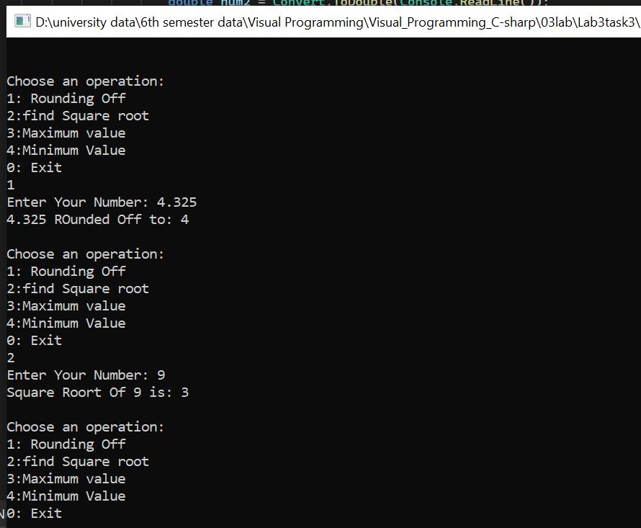

Task 4:
Q4. Create a C# application where the user enters any integer, and the program determines whether the number is an Armstrong number or not. An Armstrong number is one whose digits raised to the power of the number of digits add up to the original number (e.g., 153 → 1³ + 5³ + 3³ = 153). Use loops to extract digits, if-else to compare results, and display a final message stating whether the number qualifies as an Armstrong number.
CODE:
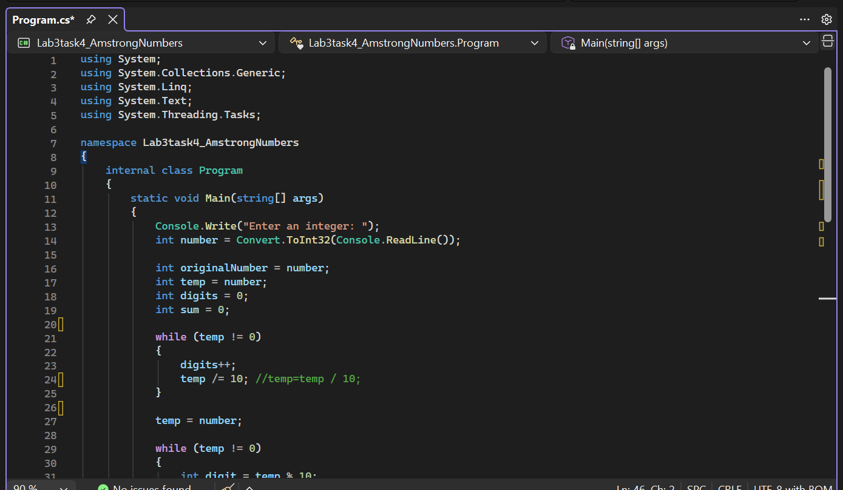
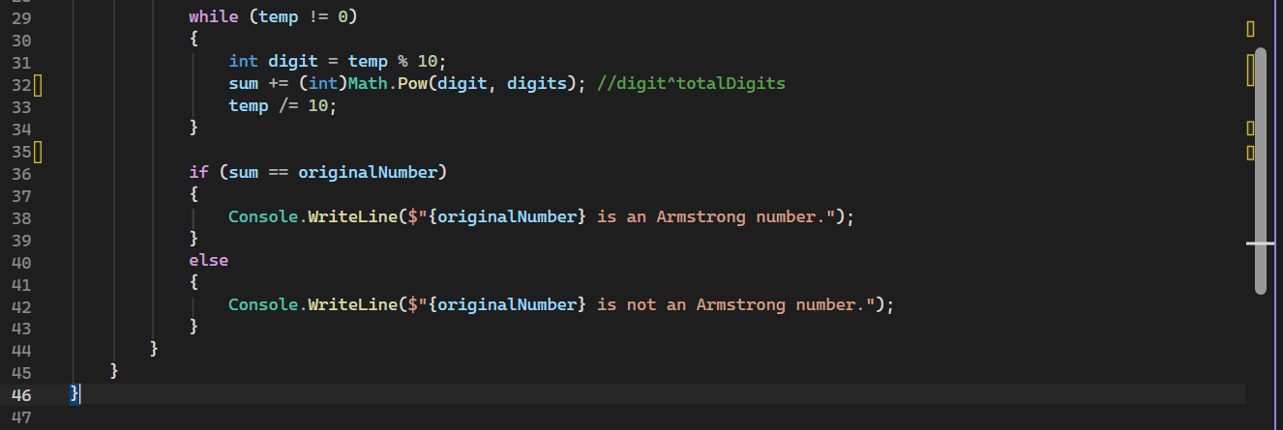
OUTPUT:
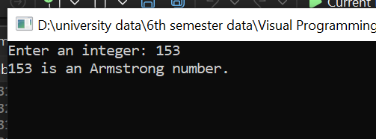
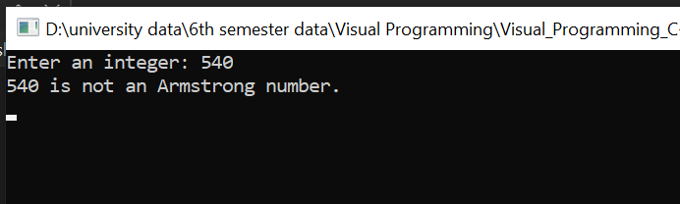

END;

